Studio 14a (12/04/06): Electrochemical Cells
1) Predict the potential difference created in reduction/oxidation reaction.
2) Understand and use a standard table of electric potentials.
3) Determine the effects of concentration and temperature on electrochemical cells

Reading: 19.4-19.5 p 921-930; 19.7 p 934-935;
Group Roles: A Leader; B Recorder; C Technician
Studio 13c introduced electrochemical cell as devices in which the transfer of electrons takes place through an external pathway, rather than directly between the reactants due to the potential difference between anode and cathode. A voltmeter is used to measure potentials as shown in Figure 1.
Figure 1: Voltmeter measuring cell potential
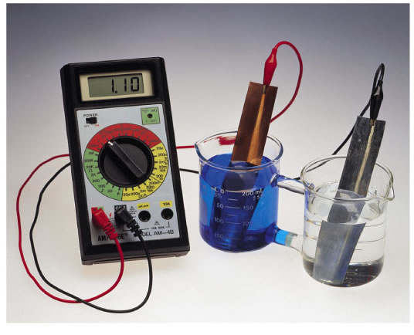
The voltmeter has two clips that are colored red and black. When the red clip is connected to the anode and the black clip is connected to the cathode, a positive voltage is detected as shown in Figure 1. If the clips are backwards, a negative voltage is detected.
In order to practice using the voltmeter, you can measure the potential of a closed battery. Turn on the meter and if it is not set to voltage push the "+" button once or twice.
1) Measure the potential difference of a AA (1.5 V) battery. Is the battery fully charged, or has it been used significantly? Which end is the cathode and which is the anode?

All of the electrochemistry is hidden inside of the battery, so to see how electrochemical cells work, you will have to build your own.
1) Question: Can you predict the potential of an electrochemical cell?
Data/Fact Gathering:
Investigate the reducing potential of four different metals: copper, nickel magnesium, silver and zinc, by constructing electrochemical cells to measure the potential of all possible combinations of metal/metal ion half cells given the following supplies:
0.1 M Ni(NO₃)₂ | 24 well microplates
0.1M Cu(NO₃)₂ | Disposable pipets
0.1M Zn(NO₃)₂ | Wires or narrow strips of copper, zinc, iron, magnesium and silver
0.1M Mg(NO₃)₂ | Steel wool
0.1M AgNO₃ | Voltmeter & alligator clips
salt solution (KNO₃) | Filter paper
A complete electrochemical cell requires two half-cells, a salt bridge, and an external connection in order to complete its circuit.
Figure 2: Half-cell 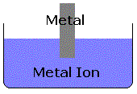
Each half of the cell should be constructed by placing a metal electrode in a solution which contains ions of that metal. For example, copper wire goes in the copper(II)nitrate solution (Figure 2.)

Some questions and tips to get you started:
- What is the steel wool for?
- What are the filter paper and salt solution for?
- Use the table below to help you organize the experiment.
- DO NOT throw away the metal electrodes...they can be reused.
Table 1: Electrochemical Cell Voltages
Black Lead | Red Lead
Black Lead | Copper | Magnesium | Silver | Zinc | Nickel
Copper
Magnesium
Silver
Zinc
Nickel

Evaluation
1) What range of potentials can you measure from the materials available?

2) Which combination of metals created the greatest potential difference?

3) Which metal became the anode most often?

4) Which metal became the cathode most often?

5) How do your findings relate to the activity series you created in Studio 13b?

6) Do you think that changing the metal counter ion from nitrate to sulfate would affect the potential of the cell? Why or why not?

7) Can you use a mixed metal/metal ion solution as a half cell? For example, could you put zinc in copper nitrate or copper in zinc nitrate? Do you get the same voltage? Explain.

8) For 3 of the cells you tested, write out the half-reactions taking place at the anode and cathode along with the balanced net ionic equation.

Data/Fact Gathering
Having to measure the potentials of all possible cells isn’t always the most convenient approach, so a Table of Standard Reduction Potentials has been compiled (Table 2.)

Table 2: Table of Standard Reduction Potentials (Table 19.1 from your text)
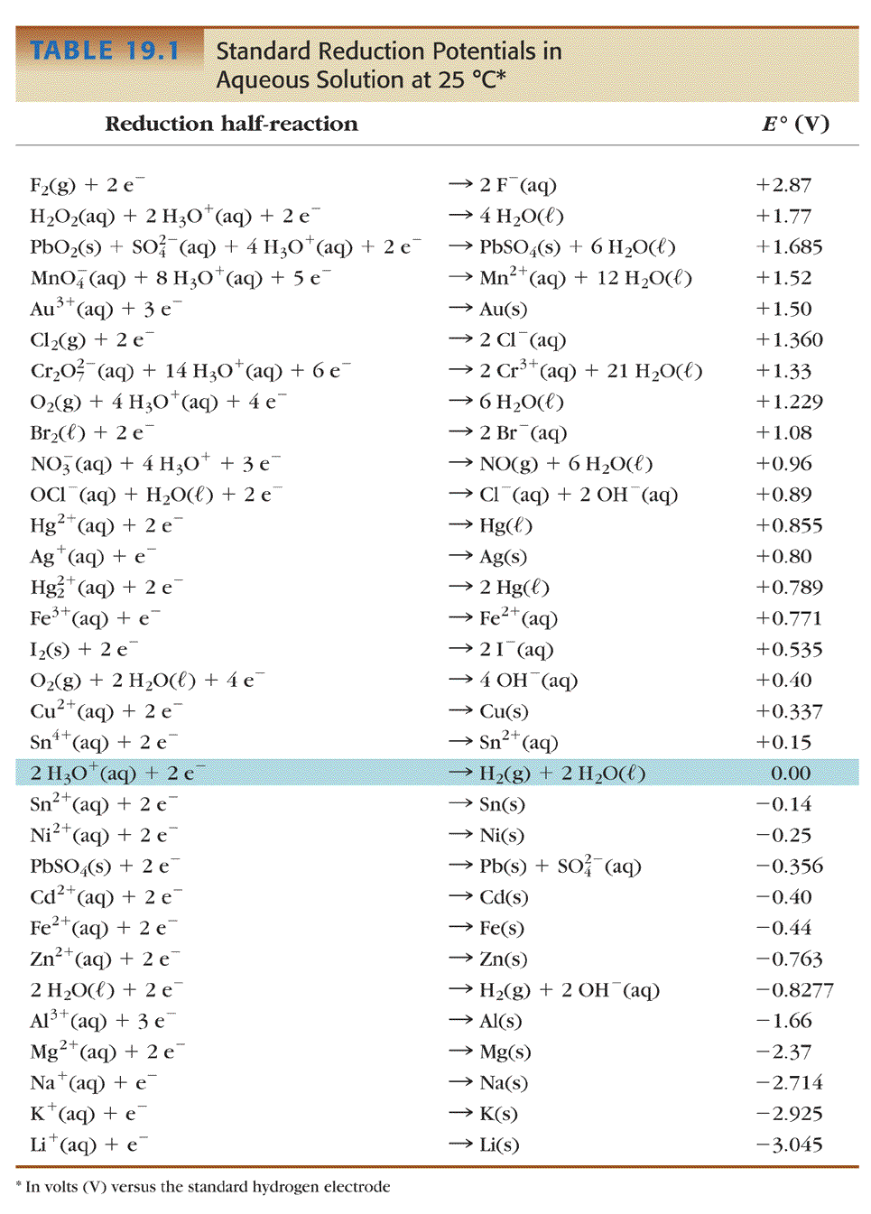9) What do all of the reactions have in common?

10) How is the table ordered?

11) How does this order relate to you activity series?

In order to find the potential for an electrochemical cell, one uses the following equation:
E_{cell} = E_{cathode} - E_{anode} (where E_{cathode} and E_{anode} are the reduction potentials from Table 2)

For example for the Zn/Zn⁺²/Cu/Cu⁺² cell
Cathode: Cu⁺² + 2e⁻ → Cu +0.337 V
Anode: Zn⁺² + 2 e⁻ → Zn -0.763 V

E_{cell} = E_{cathode} - E_{anode}
E_{cell} = 0.337 – (-0.763)
= 1.100 V

Note that all reactions are written as reduction reactions in Table 2. Oxidation reactions still take place at the anode (It is Zn → Zn⁺² + 2 e⁻). The negative sign in the E_{cell} equation takes this into account and it is the reduction potential from the table that should be plugged in even for the anode.

12) Combinations of half reactions that yield an E_{cell} > 0 are spontaneous and the more positive the more highly favored. Any pair of half reactions listed in Table 2 can be combined to make an electrochemical cell with a positive E_{cell}, it is just a matter of selecting which will be the anode and which the cathode. For the following pairs of reactions, which would be the anode?

a) Zn⁺² + 2 e⁻ → Zn b) Zn⁺² + 2 e⁻ → Zn c) Zn⁺² + 2 e⁻ → Zn
Fe⁺² + 2e⁻ → Fe Al⁺³ + 3 e⁻ → Al Au⁺³ + 3 e⁻ → Au

13) Find the standard cell potentials for all cells that you measured.

14) How do the potentials you just calculated compare to those you measured?

Question
The standard potentials in Table 2 were measured in 1.0 M solutions (of metal cations) at 25ºC. Do concentration and temperature matter that much?

Data/Fact Gathering:
Determine the effects of concentration and temperature on electrochemical cells. Examine the effect of changing metal ion concentrations in an Ag/Cu cell by measuring the potential of the following galvanic cells:
Copper | Silver
Copper | 0.05M | 2.0M
0.05M
2.0M
15) Describe any trends in the data (include your initial data from Table 1 and the standard reduction potential).

16) What conclusions can you draw about concentration and cell potential?

17) Can you make any predictions about ways to increase cell potential?
Explore the effect of temperature by using an ice bath and a hot plate, to measure the Zn/Zn⁺²/Cu/Cu⁺² cell at different temperatures.
(Caution: To decrease the temperature, use small vials for the half-cells and place the vials in an ice bath. Wait a few minutes for the half-cell solutions to reach thermal equilibrium with ice bath and then measure the cell potential.
To increase the temperature, use small beakers or large vials for each of the half-cells. Clamp in place the half-cells on a hot plate and use the thermometers in your drawers to measure the temperature. Use stir bars to mix the solutions in the half-cells evenly while they are heating.)
18) How does the cell potential change if the temperature is decreased? What would happen to the cell potential if it were running outside in Ann Arbor in November (average temperature 28ºF)?

19) How does the cell potential change if the temperature is increased? (What about the cell potential in Death Valley in July (average temperature 101ºF)?

The Nernst equation shows the mathematical relationship between the standard cell potential and half-cell concentrations and temperature.
The equation was first developed by Hermann Walther Nernst – hence the name “Nernst Equation.” Walther Nernst was awarded the 1920 Nobel Prize in Chemistry for his work in electrochemistry and thermochemistry
E = Eº - RT (ln Q)
nF
Eº = standard potential of the cell calculated from Table 2
R = Universal gas constant = 8.3145 J/mol*K
T = temperature in Kelvin
n = number of electrons transferred
F = Faraday’s constant = 96,4834 C/mol = 9.64834 x 10⁴C/mol
Q = reaction quotient (concentration of anode divided by the concentration of the cathode (same as equilibrium)

